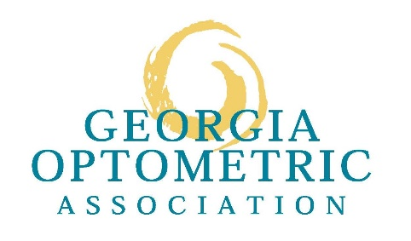
For Release: IMMEDIATE Media Contact
Dan Curran for Georgia Optometric Association
770-658-9586 or DanCurran@CurranPR.com

Georgia Eye Doctors Issue ‘Friend Alert’ Urging Public to
Tell Friends About Eye Drops Recall
Contaminated Eye Drops Impact 81 Patients in 18 States with
14 Cases of Vision Loss, Four Deaths & Four Eye Removals

Atlanta, Ga. (May 24, 2023) – Georgia’s doctors of optometry have issued a FRIEND ALERT, urging the public to tell their friends and acquaintances about the eye drops recall that has now impacted 81 patients in 18 states. Fourteen people have experienced vision loss, four people have died and four others have had to have their eyes removed surgically, according to the Centers for Disease Control & Prevention.

The products, EzriCare and Delsam Pharma’s Artificial Tears and Delsam Pharma Artificial Ointment, which were manufactured by Global Pharma Healthcare based in India, were recalled in February over potential bacterial contamination – linked to the multistate outbreak of an extensively drug-resistant strain of Pseudomonas aeruginosa.

The outbreak is continuing to grow with new cases being reported and, late last week, a fourth death confirmed. The 18 states where cases have been confirmed by state and local health departments are California, Colorado, Connecticut, Delaware, Florida, Illinois, North Carolina, New Jersey, New Mexico, Nevada, New York, Ohio, Pennsylvania, South Dakota, Texas, Utah, Washington and Wisconsin, according to the CDC. https://www.cdc.gov/hai/outbreaks/crpa-artificial-tears.html

“Eye drops are safe when manufactured and used properly,” said Dr. John Titak, president of the Georgia Optometric Association. “This is an incredibly rare case with a new form of drug-resistant bacteria never before reported in the United States prior to this outbreak. With the number of cases growing, we need the public to tell their friends, loved ones and acquaintances to check their medicine cabinets for these products and throw them away.”

EzriCare was the brand of eye drops used by most patients and was the only product identified in the four health care facilities where cases have arisen, the CDC says. The CDC found the bacteria strain in opened EzriCare bottles collected from patients and the Food & Drug Administration found contamination in unopened bottles, the agencies say.

Patients that have used these products or experience any new and/or prolonged irritation in their eyes should visit GOA.org to book an appointment with a Georgia doctor of optometry. Eye infection symptoms may include:
- Yellow, green, or clear discharge from the eye
- Eye pain or discomfort
- Redness of the eye or eyelid
- Feeling of something in your eye (foreign body sensation)
- Increased sensitivity to light
- Blurry vision

Regardless if an individual experiences obvious symptoms, anyone who has used these products should alert their doctor of optometry so they may assess the front surface of their eye for any problems during a comprehensive eye exam. Find an optometrist near you at www.GOAeyes.com by using the ZIP code locator tool.

-30-

About the Georgia Optometric Association
The Georgia Optometric Association is a statewide professional organization representing more than 700 doctors of optometry serving communities throughout the state of Georgia. Founded in 1904, the GOA and its members work to provide the public with quality vision and eye care services. For more information visit www.GOAeyes.com, www.facebook.com/GeorgiaOptometricAssociation or follow www.Twitter.com/GOA_eyes.

